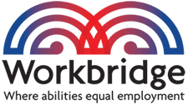
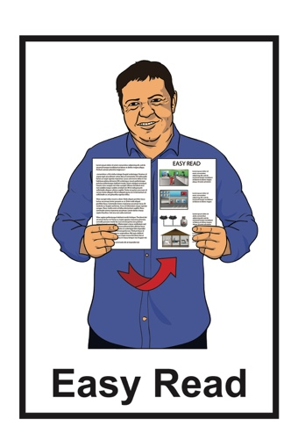

Working for you:
How should Workbridge be governed in the future?
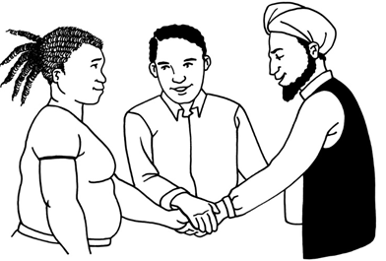

April 2022
About this document

This Easy Read document looks at:

- how governance works at Workbridge

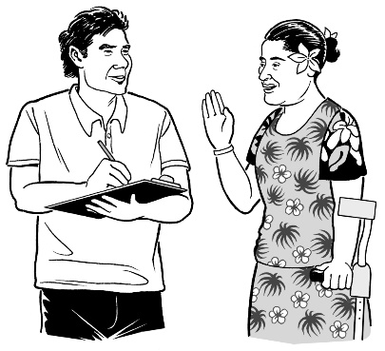
- what changes are needed to make governance work well in the years to come

- how you can have your say about the changes.

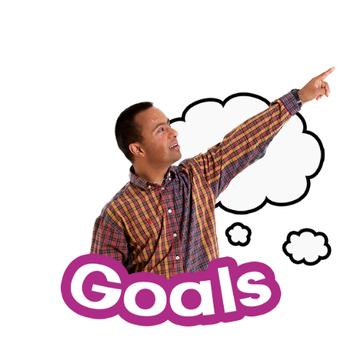
Governance is when a group of people work together to make sure an organisation:

- does what it sets out to do

- works well so that it can reach its goals.

How Workbridge is governed now

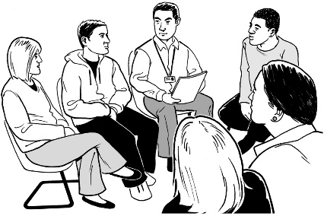
Workbridge is governed by a:

- Council
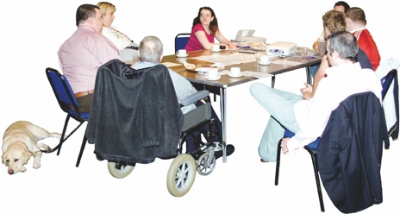
- Board.

The Council and the Board do different things.

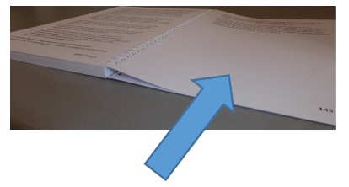
We look at what the Council and the Board do on pages 3 to 4.

You can also find more information about who is on the Council and the Board on the Workbridge website:

https://workbridge.co.nz/our-people

What the Workbridge Council does

The Council is mostly made up of people who come from disabled peoples organisations.

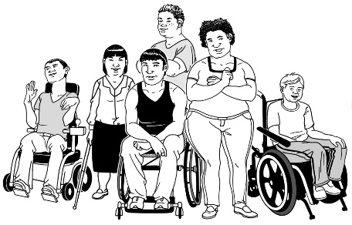
These organisations are also called DPOs.

Having people from DPOs on the Council is to make sure that disabled people decide how Workbridge is run.

The Council:
- gives advice about how Workbridge is run
- decides who is on the Board

- makes changes to the rules.

What the Workbridge Board does

The Board:

- chooses who is the Chief Executive of Workbridge
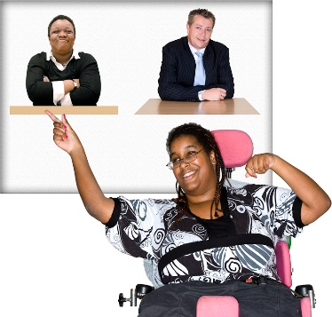
- works on the strategic plan

- reports to the Council about the work being done.

The Chief Executive:

- is the person who oversees the work that Workbridge does

- reports to the Board about the work being done.
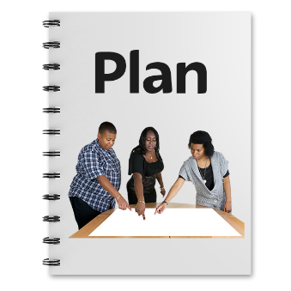
The strategic plan looks at what Workbridge should be doing in the years ahead.
Why are we thinking about governance?

The Council and the Board:

- have been looking at how governance works at Workbridge

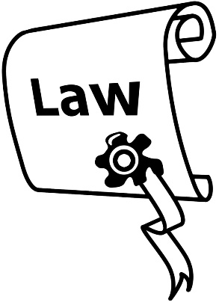
- know that soon there will be a change in the law about incorporated societies.

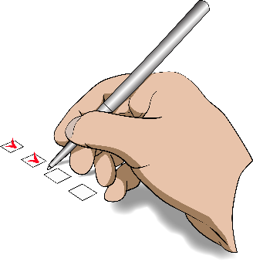
An incorporated society is a membership based organisation that has registered under a law called the Incorporated Societies Act 1908.

The law is like a guide for people who run societies or groups.
1908

The law was written over 1 hundred years ago.

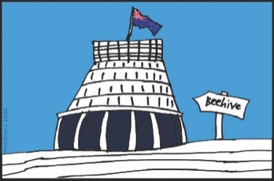
The Government is now looking at this law so it fits better with how things are done today.

Workbridge is an incorporated society.

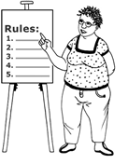
With the new law changes that are coming Workbridge will need to make some changes to its Constitution.

The Constitution is the rules that say what Workbridge:

- can do

- who in the organisation can do what.

The Constitution rules for Workbridge were written a long time ago.

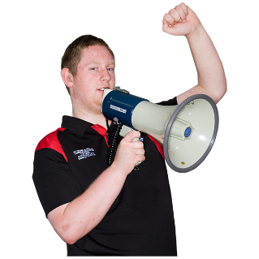
Since the rules were written disabled people want to have a greater say about the services they use.

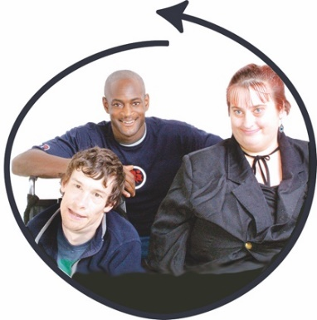
We sometimes describe this by saying:

Nothing about us without us.

There have also been changes in the way that the government funds the work that Workbridge does.

Workbridge used to get the same amount of money every year from the government.

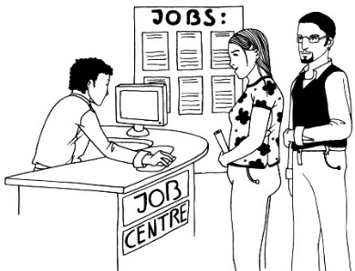
Now the money that Workbridge gets depends on:

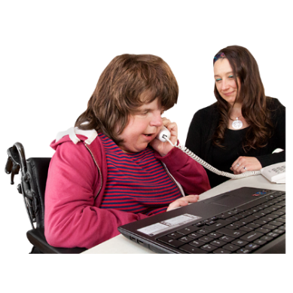
- how many people come to Workbridge to get support with finding work

- how long someone stays in a job.

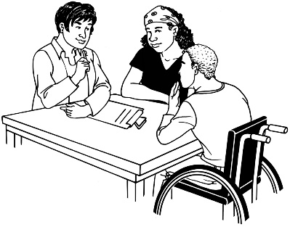
All these things mean that there has been a lot of change in the way Workbridge does things.

Now is a good time to think about changing the way Workbridge is set up.

Ways that Workbridge could change

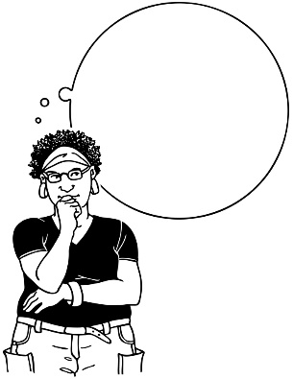
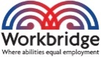
The Council and the Board have been thinking about how governance at Workbridge could work in the years to come.

The Council and the Board think it would be easier if there was 1 group of people who govern Workbridge.

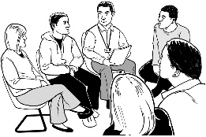
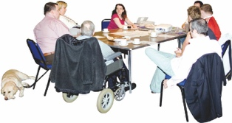
This would mean having just 1 group rather than 2 groups who govern Workbridge.

The Council and the Board have not yet decided if that is what Workbridge should do.

The Council and the Board want to hear from you about how you think:
- Workbridge should be governed

- about having a Consumer Council.

A Consumer Council would:

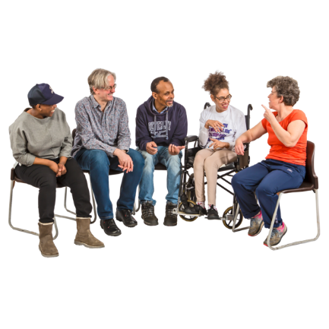
- be made up of people who use Workbridge services

- mean that people who use the services can have a say in the work that Workbridge does.

How to have your say

The Council and the Board have 4 important questions to ask you about governance.

Question 1:

At the moment Workbridge has a Council and a Board.

Should we:
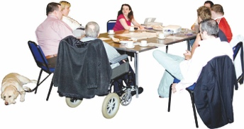
- keep having 2 groups in charge?

or
- have 1 group in charge?

Question 2:
How could we make sure we keep listening to the people who use our services?

Question 3:
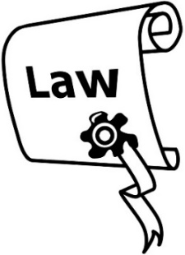
Workbridge is an incorporated society at the moment but incorporated society laws are going to change soon.

Should we stay an incorporated society or change to something else?

Question 4:
When we think about whether we are an incorporated society or something else what are the important things that will help us make the right choice?
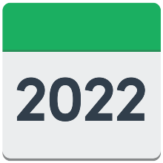
You need to tell us what you think by 31 May 2022.

You can:
- email your answers to:

governance@workbridge.co.nz

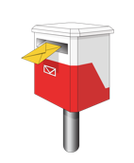
- write to us and post your answers to:

Workbridge National Office
PO Box 2560
Wellington 6140

- fill in the form on our website:

http://workbridge.co.nz/governance

This information has been written by Workbridge.
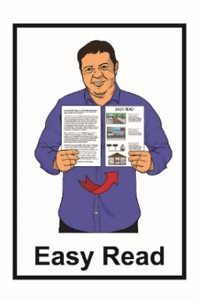
It has been translated into Easy Read by the Make It Easy service of People First New Zealand Inc. Ngā Tāngata Tuatahi.

The ideas in this document are not the ideas of People First New Zealand Inc. Ngā Tāngata Tuatahi.
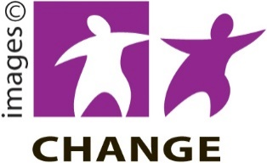
Make It Easy uses images from:

- Changepeople.org
- Photosymbols.com
- Sam Corliss
- Huriana Kopeke-Te Aho.

All images used in this Easy Read document are subject to copyright rules and cannot be used without permission.

